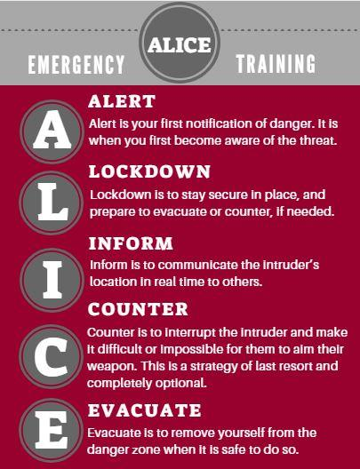

Haverhill Public Schools

4 Summer St.

Haverhill MA 01830

978-374-3400



**Who is ALICE?** ALICE started as a small school security training company. ALICE has been dedicated to promoting proactive strategies to improve the chances of survival during an active shooter event. Since they have worked with hundreds of thousands of individuals in [Police/LE](https://www.alicetraining.com/our-program/alice/law-enforcement/), [K-12 Schools](https://www.alicetraining.com/our-program/alice/k12-education/), [Healthcare](https://www.alicetraining.com/our-program/alice-training/healthcare/), [Higher Education](https://www.alicetraining.com/our-program/alice/universities/), [Business](https://www.alicetraining.com/our-program/alice/workplace/), [Government](https://www.alicetraining.com/our-program/alice-training/government/) and [Houses of Worship](https://www.alicetraining.com/our-program/alice/worship/) organizations and empowered their people using ALICE Training. ALICE’s drive to make a difference and continue to lead the evolution in active shooter response tactics is at the core of what makes the solutions so effective. At the ALICE Training Institute, they are always working to create new stories of improvement. From teachers and healthcare professionals to police and everyday citizens, active shooter training classes teach skills that improve your chances of survival anywhere you go in life.

**Why did we choose ALICE?** ALICE Training was the pioneer in active shooter preparation training in our country. They were the first program to question the reasonableness of “lockdown-only” policies and training.

**Why does HPS need ALICE?** Why change from “traditional” lockdown-only policy? There is a new standard-of-care which emphasizes the need for proactive, options-based strategies. The federal and state government recommendations, as well as, major law enforcement associations support ALICE strategies. ALICE is the model upon which these official recommendations were built. We have to come to the realization that a violent critical incident can happen any time, any place and for any reason. We at HPS have a responsibility to those in our care and employment to do all we can to prepare them for this rare event, not only in our location but wherever they may find themselves in the future. **PROACTIVE VS REACTIVE**

**Does this mean our schools are not safe?** Schools are some of the safest places for our children because most schools practice evacuation drills for fires and protective measures for natural disasters, but far fewer schools practice for active shooter situations. To be prepared for an active shooter event, schools should train their staff, students, and families, as appropriate, in what to expect and how to react. Best practices include the involvement of students in the training. All Training is done based on the age of the student and usually done with their teacher leading the training. This includes using the ALICE Training children’s book, “I’m not Scared…I’m Prepared” and the associated classroom workbook for teachers.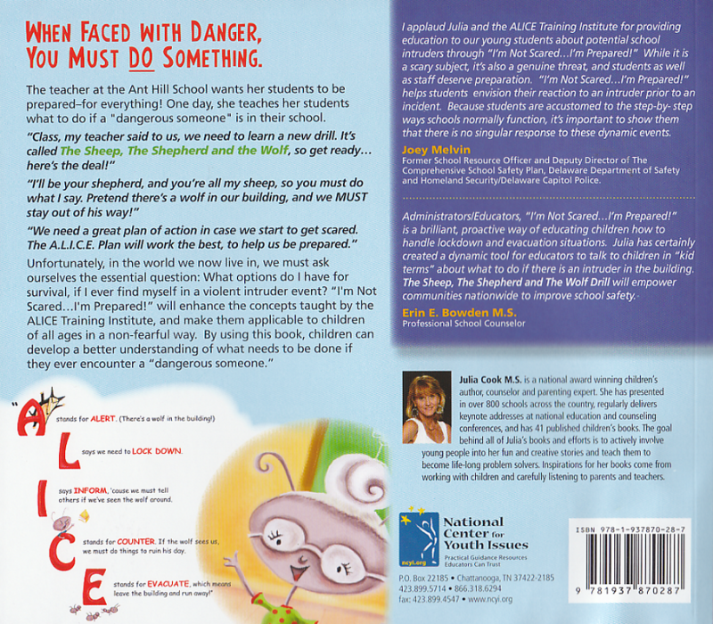

**What about our students with special needs, will they have the support they need?** As with most issues with our special needs population, planning and preparations to accommodate their needs will be required. In a response, we will only ask them to use the parts of ALICE that makes sense for their abilities. Each school will have to consider and use special communications, training and building infrastructure developed to help them become more ready for this event.

During this brief Q and A it is difficult to think of every question, you might have.

Should you have any concerns please reach out to any of us and we will do our best to answer your questions.

***Thank you for attending,***



Scott Gray, scott.gray@haverhill-ps.org

Lea Anne Waybright, leaanne.waybright@haverhill-ps.org

Cara LaBelle, clabelle@haverhill-ps.org

Paula Rodriguez, prodriguez@haverhill-ps.org

Thank you to Superintendent Margaret Marotta and the Haverhill Police Dept for their continued support.