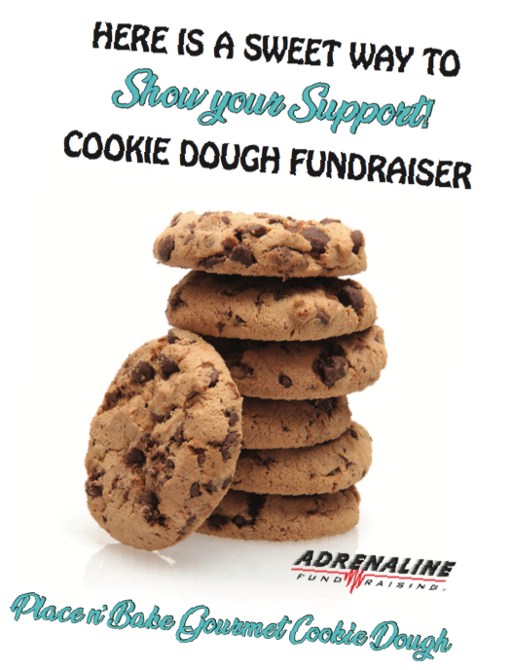
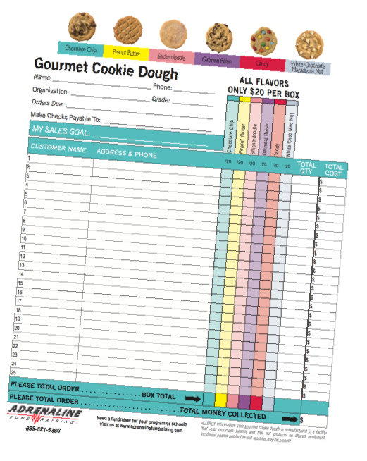
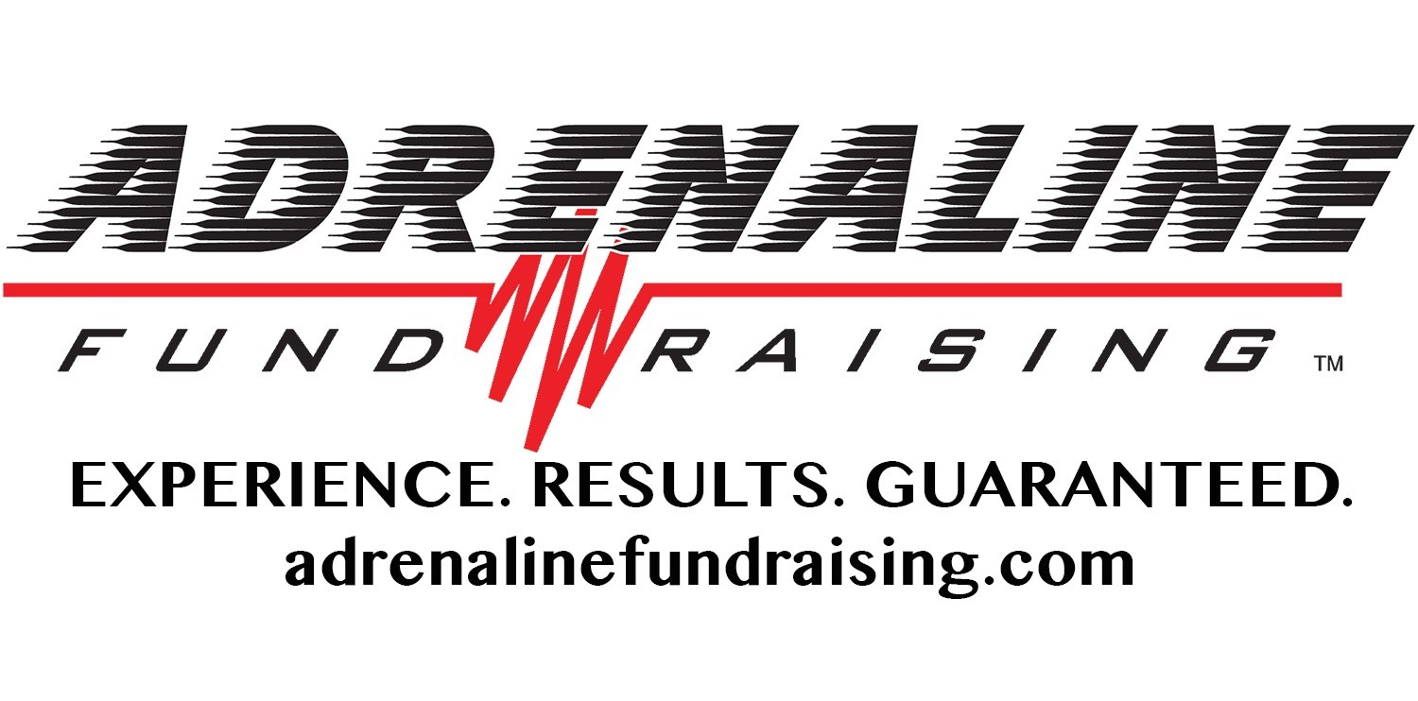
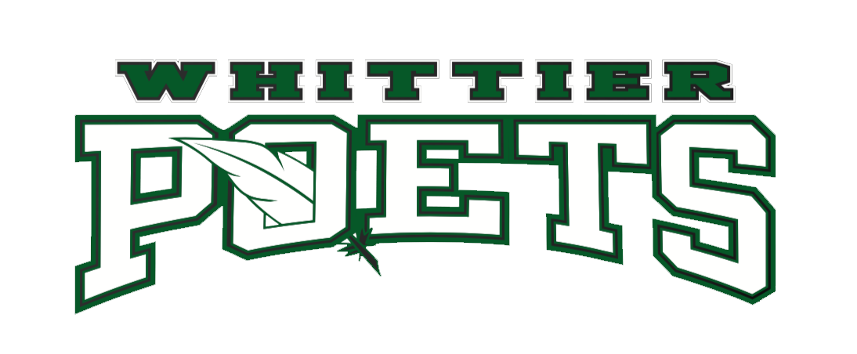
♦ J.G. WITTIER MIDDLE SCHOOL ♦
COOKIE DELIVERY DAY!
ATTENTION ALL WHO PARTICIPATED
IN THE COOKIE DOUGH FUNDRAISER...

COOKIE PICK UP DAY:
Friday, December 17, 2020
J.G. Whittier Middle School
3-5PM
Drive up to the cafeteria side door & your
Cookie order will be placed in your car

PLEASE NOTE-
THE COOKIES ARE PERISHABLE &
MUST BE KEPT FROZEN IF YOU
DO NOT PLAN TO DELIVER THEM THE
SAME DAY TO THE STUDENT'S CUSTOMERS.

Thank you for participating in the cookie fundraiser!
We greatly appreciate your support!

WHEN WILL I RECEIVE MY FUNDRAISER PRIZE(s)?
Prizes will be available in a few weeks! Stay tuned for more information to follow.

10-14 SOLD: Custom long sleeve Dri-fit with school logo!
15-19 SOLD: $50 Amazon gift card!
20+ SOLD: $25 Amazon gift card and custom Under Armour backpack with school logo!

